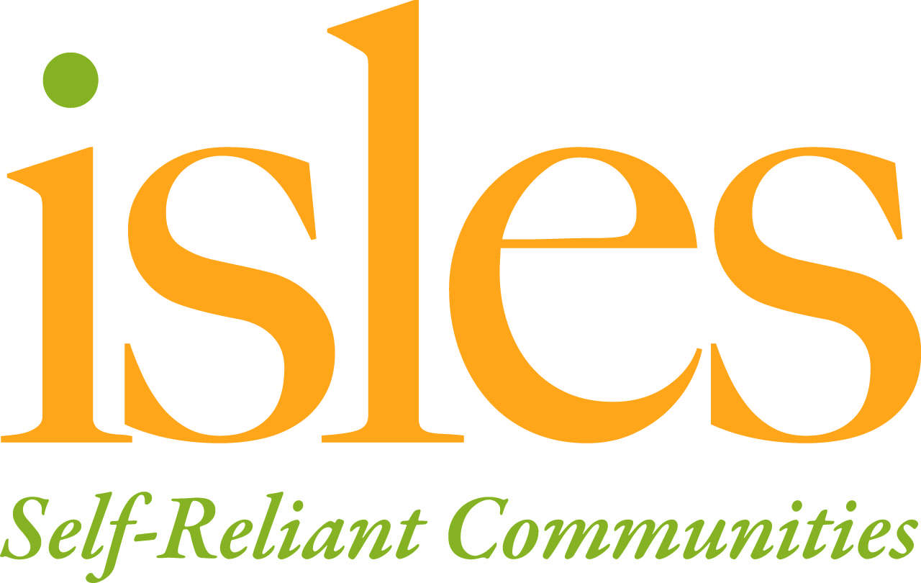
Founded in 1981 by students and faculty of Princeton University, Isles is an award-winning nonprofit community development and environmental organization, with a mission to foster self-reliant families and healthy, sustainable communities.

Group and Corporate Volunteers
The rise of social responsibility means that large corporations and small organizations alike are eager to positively contribute to society and take part in social justice, protecting the environment or adding to their local community.

Corporate and community groups of volunteers bring skills, enthusiasm, and experience to Isles, and partnering with a business, corporation or organization increases publicity while raising social awareness of the issues in our community.

Our Programs
Isles has a long history of hosting groups of volunteers, and we are proud of the partnerships we have established. Depending on the current needs, we can hosts groups up to 100* people when projects arise that can accommodate that size group. In the past, corporate groups have helped build gardens, renovate parks, and restore buildings. Isles’ projects are always evolving, so contact us to learn about our upcoming projects.
*Large groups will be broken down to teams of no more than 20 for ease of management.

Benefits of Partnership
If we agree to work with your group, you can be assured that the work you will be engaged in has an impact on the community.
We will work with your group to develop a plan and identify resources for a successful experience.
We will communicate clearly what your staff will need in order to be prepared for the event.
We will introduce you to our work and the progress we have made in the community.
We will provide suitable supervision while your group is on site.
We will have adequate safety procedures in place.
We will publicly acknowledge your work.

Questions to Consider
Does your group share the ideals of Isles? Learn more at www.isles.org.
Can your group allocate resources to ensure volunteers have a positive and meaningful experience?
Can your group make a gift to help offset the costs of hosting your event?

Contact 609-341-4738 for more information or fill out the attached form and return it 6 weeks before your desired project date.

Group Volunteer Interest Form
Date __________________
Name of Group/Corporation _________________________________
Has your group work with Isles before? ___no ___yes
If yes, when and in what capacity?___________________________________________
Name of contact person(s)________________________email______________________
Phone________________________ Address_____________________________________
Size of your group? _________________________
If members are under 18, how many chaperones will you have? ____
Does anyone in your group have physical limitations and what accommodations are requested? ____________________________________________________________________________________________________________________________________________________________
What does the group hope to gain from volunteering with Isles?
____________________________________________________________________________________________________________________________________________________________________________________________________________________________
Are you able to provide your own transportation and meals? _______
Please list your preferred dates and times
____________________________________________________________________________________________________________________________________________________________

Level of Participation
We will work with each group individually to create projects that match the needs with your group’s resources. To begin this process, please select the group size and time frame that best matches your organization’s needs.

______ A half-day project for groups up to 10 that includes a brief orientation to the work of Isles and up to 3 hours working with our staff in an area garden or building project. Suggested contributions begin at $500.

______At this level, your contribution will provide equipment and materials to increase the impact of your project. Project runs from ½ to one full day for a group of 10 to 20 and includes a brief orientation to the work of Isles. Suggested contributions begin at $1000.

Send to:
Volunteers at Isles
10 Wood Street
Trenton, NJ 08618

Or email:
volunteers@isles.org

